**Tribhuvan University**



**Bachelors of Science in Computer Science and Information Technology (BSc. CSIT)**

**A PROJECT REPORT ON**

**“Online Tutor”**

**Submitted to**

**Department of Computer Science and Information Technology**

**Lumbini ICT Campus**

In partial fulfillment of the requirements for Bachelors in Computer Science and Information Technology

**Submitted by**

**Nishu Sapkota (TU Reg. No: 5-2-1194-34-2018)**

**Roshan Bahadur Basnet (TU Reg. 5-2-360-27-2018)**

**Thani Sara Gaha (TU Reg. No: 5-2-1194-47-2018)**

**Under the Supervision of – Er. Modnath Acharya**

**ACKNOWLEDGEMENT**

Firstly, I would like to express our deep and sincere gratitude to LUMBINI ICT COLLEGE for providing opportunity, necessary resources and guidelines to come up with this project.

I would like to express immense gratitude to our respected teachers for their constant support, enthusiasm been interest in this project despite having hectic schedule. Their advice on technical matters is invaluable and their guidance id very critical for the success of our project.

Also, I grateful and fortunate enough to have Er. Modnath Acharya as my supervisor, who encouraged to go ahead with this project. He helps me as good instructor.

I thank all the people for their help directly and indirectly to complete my project.

Nishu Sapkota

Roshan Bahadur Basnet

Thani Sara Gaha

**ABSTRACT**

The Online Tutor project is a web-based platform designed to provide an interactive learning experience to students who require additional academic assistance. The system has three primary users: admin, tutor, and student. The admin is responsible for managing the system by adding tutors, students, courses, faculty, and maintaining their profiles. The tutor has the ability to assign homework, upload notes, and post informative content. The student can access the tutor's materials, submit their assignments, and engage in discussions with other students.

The system is built on a user-friendly interface that allows for easy navigation between features. The administrator has full control over the system, including adding, editing, and deleting users and courses. The tutor can upload their materials, create assignments, and respond to students' questions. The student has access to all the learning resources provided by the tutor, can submit their assignments, and engage in discussions with other students.

Overall, the Online Tutor project aims to create a supportive learning community where students can receive personalized academic support and improve their academic performance. With the use of advanced technology, the system provides a seamless and efficient learning experience for both students and tutors.

Contents

Chapter 1: Introduction 1

1.1 Introduction 1

1.2 Statement of the problem 1

1.2 Objectives 2

1.4 Project Question 2

1.5 Report Organization 3

Chapter:2 Background Study and Literature Review 3

2.1 Background Study 3

2.2 Literature Review 4

Chapter 3: Methodology 5

3.1 Requirement Engineering 6

3.1.1 Feasibility Study 6

3.1.2 Requirement Collection 8

3.1.3 Requirement Analysis and Validation 9

3.1.4 Software Requirement Specification 9

3.1.5 Data Modeling (ER-Diagram) 13

3.1.6 Process Modeling 14

3.2 System Design 17

3.2.1 Architecture Design 17

3.2.2 Database Schema Diagram 19

3.2.3 Interface Design 20

Chapter 4: Implementation and Testing 21

4.1. Implementation 21

4.1.1. Tools Used 21

4.2 Testing 24

4.2.1 Unit Testing 24

4.2.1.1 Test cases 24

4.2.2 Features Testing 27

Chapter:5 Risk Analysis 27

Chapter:6 Conclusion and Discussion 28

References 30

Appendix 31

**LIST OF FIGURES**

Figure 1 :Incremental Model 6

Figure 2:Schedule Time 8

Figure 3: Use Case Diagram 11

Figure 4: ER Diagram 13

Figure 5: Level-0 DFD 14

Figure 6: Level-1 DFD 15

Figure 7: level-2 (Data Maintaining System) 16

Figure 8: Level-2(Learning Resource Circulation System) 17

Figure 9: Architecture Design 18

Figure 10: Database Schema Desig 19

Figure 11: Admin Login 31

Figure 12: Dashboard 32

Figure 13: Student Information 32

Figure 14: Course data 33

Figure 15: Adding Course details 34

Figure 16: tutor dashboard 34

Figure 17: Uploading Assignment 35

Figure 18: Student Dashboard 35

Figure 19: Student viewing assignment and uploading 36

Figure 20: Notes uploading page 36

Figure 21: view student’s assignment 37

**LIST OF TABLES**

Table 1: Admin login 25

Table 2: Student login 26

Table 3: Tutor login 27

# Chapter 1: Introduction

## Introduction

The Online Tutor project is a web-based platform designed to provide an interactive learning experience to students who require additional academic assistance. The project aims to create a supportive learning community where students can receive personalized academic support and improve their academic performance. With the use of advanced technology, the system provides a seamless and efficient learning experience for both students and tutors.

The project has been developed with the goal of making learning accessible to everyone, regardless of their location or circumstances. The system has three primary users: admin, tutor, and student. The admin is responsible for managing the system by adding tutors, students, courses, faculty, and maintaining their profiles. The tutor has the ability to assign homework, upload notes, and post informative content. The student can access the tutor's materials, submit their assignments, and engage in discussions with other students.

The project has been developed with a user-centric approach, ensuring that the system is easy to use and provides an intuitive user interface. The project also uses advanced security protocols to ensure that user data and privacy are protected.

We believe that the Online Tutor project has the potential to revolutionize the way students learn and interact with their tutors. We hope that this project will be a valuable tool for students, tutors, and administrators alike, and will contribute to the development of a more inclusive and effective educational system.

## 1.2 Statement of the problem

The education sector has undergone significant changes over the years, with the emergence of technology revolutionizing the traditional teaching and learning methods. However, despite the advancements, many students still struggle to grasp academic concepts due to limited access to academic resources, lack of personalized attention, and a rigid learning environment. The Online Tutor project aims to address these challenges by providing an interactive and personalized learning experience to students who require additional academic assistance.

The current education system also presents a challenge for tutors who struggle to provide personalized attention to each student due to the large class sizes. This challenge is further compounded by the limited access to academic resources, which makes it difficult for tutors to provide comprehensive learning materials to their students.

The Online Tutor project addresses the above challenges by creating a supportive learning community where students can receive personalized academic support from tutors. With the use of advanced technology, the system provides a seamless and efficient learning experience for both students and tutors.

In summary, the Online Tutor project addresses the following problems:

Limited access to academic resources.

Lack of personalized attention to students.

Large class sizes and rigid learning environments.

## Objectives

The Online Tutor project has the following objectives:

* To provide a personalized learning experience
* To enhance accessibility to academic resources
* To foster a supportive learning community
* To improve academic performance
* To streamline administrative tasks

## 1.4 Project Question

Some of the questions that are asked which is used to fulfill the requirement for the project are:

1) What are the requirements need for online tutor?

2) How the whole system work?

3) How the new technology will have an impact on old System?

4) Why this system is beneficial?

## 1.5 Report Organization

**Chapter 1**: Introduction puts emphasis on overview, Problem Statement, Objectives, Scope and Limitation of the project.

**Chapter 2**: Requirement and Feasibility Analysis is the important sections such as, Requirement Analysis and Feasibility study. Requirement Analysis explains Functional and Non-Functional requirements of the Project, and Feasibility Study explains why/how the project is practical to be implemented.

**Chapter 3**: System Design gives the design of the system developed so that it can be used during the project implementation.

**Chapter 4**: Implementation provides an indication of how the system is implemented, what tools/platform have been used. Testing clarifies the system workflow.

**Chapter 5**: Conclusion marks an end to the document by submitting up the entire project and also opening the door further for research in improving the developed system. The lesson learnt is also included in this chapter.

# Chapter:2 Background Study and Literature Review

## 2.1 Background Study

The education sector has undergone significant changes in recent years, with technology playing a crucial role in revolutionizing the traditional teaching and learning methods. The COVID-19 pandemic has further accelerated the adoption of technology in education, with many schools and universities transitioning to online learning. Online learning has several advantages, including flexibility, accessibility, and the ability to personalize the learning experience.

However, online learning also presents challenges, such as limited interaction between students and instructors, a lack of personalized attention, and limited access to academic resources. These challenges can hinder the learning process and result in poor academic performance.

To address these challenges, various e-learning platforms have emerged, providing students with access to academic resources and personalized academic support. The Online Tutor project is a web-based e-learning platform designed to provide students with personalized academic support, enhance accessibility to academic resources, and foster a supportive learning community.

The project utilizes advanced technology to create a seamless and efficient learning experience for both students and tutors. The system allows tutors to upload course materials, assign homework, and provide feedback to students, ensuring that each student receives personalized attention. Additionally, the system provides a centralized platform where students can access course materials, assignments, and academic support, enhancing accessibility to academic resources.

Overall, the Online Tutor project is designed to address the challenges of online learning by providing a personalized, accessible, and supportive learning experience that enhances students' academic performance.

## 2.2 Literature Review

The use of e-learning platforms has gained significant attention in recent years, with many institutions adopting these platforms to enhance the learning experience for students. Research has shown that e-learning platforms can improve students' academic performance, engagement, and satisfaction with the learning process (Joo et al., 2018; Lee et al., 2019).

One of the key features of e-learning platforms is their ability to provide personalized learning experiences to students. Personalized learning has been shown to improve students' academic performance by catering to their individual learning needs and preferences (Kang et al., 2018; Litzinger et al., 2017). The Online Tutor project aims to provide personalized academic support to students by allowing tutors to provide feedback and assignments tailored to individual students' needs.

Accessibility to academic resources is also a critical aspect of e-learning platforms. Students require access to comprehensive learning materials to support their learning process. Research has shown that e-learning platforms can enhance accessibility to academic resources, thereby improving students' learning outcomes (Huang et al., 2018; Yang et al., 2019). The Online Tutor project aims to enhance accessibility to academic resources by providing a centralized platform where students can access course materials, assignments, and academic support.

Furthermore, research has shown that fostering a supportive learning community is essential for improving students' academic performance and engagement (Liu et al., 2018; Wang et al., 2019). E-learning platforms can provide a conducive environment for students to collaborate and engage with peers and instructors. The Online Tutor project aims to foster a supportive learning community by allowing students to engage in discussions, collaborate with peers, and receive academic support from tutors.

In summary, the literature suggests that e-learning platforms can improve students' academic performance, engagement, and satisfaction with the learning process. The Online Tutor project aims to incorporate these key features to provide a personalized, accessible, and supportive learning experience for students

# 

# Chapter 3: Methodology

Incremental Model is a process of software development where requirements divided into multiple standalone modules of the software development cycle. In this model, each module goes through the requirements, design, implementation and testing phases. Every subsequent release of the module adds function to the previous release. The process continues until the complete system achieved.

To develop a software product, there must be a clear understanding among team representative about when and what to do. Software development life cycle plays the most important role in developing a software. Software life cycle model is a pictorial and diagrammatic representation of the software life cycle. A life cycle model represents all the methods required to make a software product transit through its life cycle stages. It also captures the structure in which these methods are to be undertaken. There are different software models to implement the SDLC like waterfall model, incremental model.

Among this, I have implemented Incremental model because my requirements were not fixed, and incremental model is more flexible to change the requirements. Risk can be easily managed using incremental model.

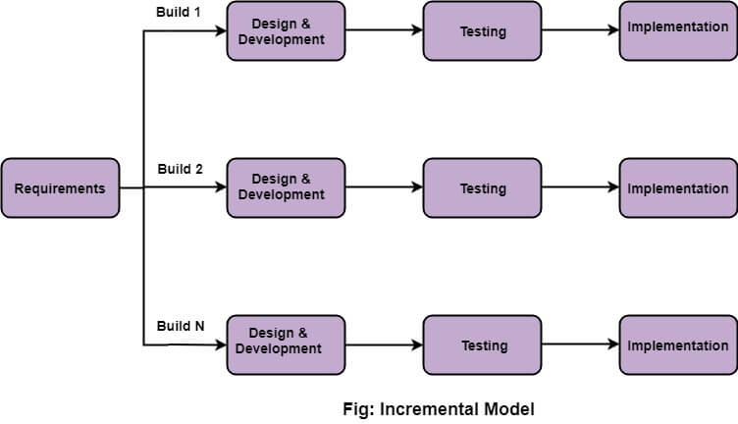

**Figure 1 :Incremental Model**

## 3.1 Requirement Engineering

### 3.1.1 Feasibility Study

The feasibility study is conducted to determine if the Online Tutor project is viable from a technical, economic, operational and schedule perspective.

For our project, we performed the following feasibility study:

1. Technical Feasibility
2. Economic Feasibility
3. Operational Feasibility
4. Schedule Feasibility

* **Technical Feasibility**

The technical feasibility of the Online Tutor project is high. The required technologies and infrastructure are readily available, and the development team has experience working with these technologies. The project can be developed using open-source software, which will reduce the development costs.

* **Economic Feasibility**

The economic feasibility of the project is high. The project has the potential to generate revenue through subscription-based models, which will cover the development and operational costs. Additionally, the project can reduce the costs associated with traditional classroom-based learning, such as infrastructure, transportation, and accommodation costs.

* **Operational Feasibility**

The operational feasibility of the project is high. The project's objectives are well-defined, and the development team has the necessary skills and expertise to deliver the project successfully. The project's success will depend on the availability and engagement of tutors and students, which can be ensured through effective marketing and outreach strategies.

* **Schedule Feasibility**

Here, we analyzed the time required to complete the project, identified that the project will fail if it took too long to complete, and determine some targeted milestones and time frames for completion as a guideline only.

|  |  |  |  |  |  |  |  |  |  |  |  |  |  |  |  |  |  |
| --- | --- | --- | --- | --- | --- | --- | --- | --- | --- | --- | --- | --- | --- | --- | --- | --- | --- |
| **S. N** | **Weeks /Stages of project** | **1** | **2** | **3** | **4** | **5** | **6** | **7** | **8** | **9** | **10** | **11** | **12** | **13** | **14** | **15** | **16** |
| **1.** | **Study and Planning** |  |  |  |  |  |  |  |  |  |  |  |  |  |  |  |  |
| **2.** | **Requirement gathering**  **And analysis** |  |  |  |  |  |  |  |  |  |  |  |  |  |  |  |  |
| **3.** | **System design** |  |  |  |  |  |  |  |  |  |  |  |  |  |  |  |  |
| **4.** | **Implementation** |  |  |  |  |  |  |  |  |  |  |  |  |  |  |  |  |
| **5.** | **Testing** |  |  |  |  |  |  |  |  |  |  |  |  |  |  |  |  |
| **6.** | **Documentation** |  |  |  |  |  |  |  |  |  |  |  |  |  |  |  |  |
| **7.** | **Presentation and Report Submission** |  |  |  |  |  |  |  |  |  |  |  |  |  |  |  |  |

Figure 2:Schedule Time

### 3.1.2 Requirement Collection

Requirement collection is a critical phase of software development, where the project team collects, analyzes, and documents the project's functional and non-functional requirements. The requirements collection for the Online Tutor project involves the following steps:

* Identify the stakeholders: The project team should identify all the stakeholders, including the admin, tutors, and students, who will use the platform.
* Conduct interviews and surveys: The project team should conduct interviews and surveys to gather feedback from the stakeholders. The interviews and surveys should be structured to collect information on the stakeholders' needs, preferences, and expectations.
* Analyze the data: The project team should analyze the data collected from the interviews and surveys to identify the common requirements and themes.
* Define the functional requirements: The project team should define the functional requirements, which specify the features and functionalities that the system should have to meet the stakeholders' needs. The functional requirements for the Online Tutor project include:
* User registration and login
* User management (admin, tutor, student)
* Course management (add, edit, delete)
* Assignment management (add, edit, delete)
* Note management (add, edit, delete)
* Post management (add, edit, delete)
* Comment management (add, edit, delete)
* User profile management
* Search functionality
* Define the non-functional requirements: The project team should define the non-functional requirements, which specify the system's performance, security, and usability standards. The non-functional requirements for the Online Tutor project include:
* Performance: The system should load quickly and respond to user requests in a timely manner.
* Security: The system should be secure and protect user data and information.
* Usability: The system should be easy to use and navigate.
* Document the requirements: The project team should document the requirements in a detailed requirement specification document that includes all the functional and non-functional requirements.

### **3.1.3 Requirement Analysis and Validation**

I conduct the review where the supervisor review for analysis and validate.

### Software Requirement Specification

A Software Requirement Specification (SRS) is a document that defines the functional and non-functional requirements of a software system. The SRS for the Online Tutor project should include the following components:

1. **Functional Requirement**

The functional requirements section should describe the system's features and functionalities that meet the stakeholders' needs. Here are some functional requirement of our project:

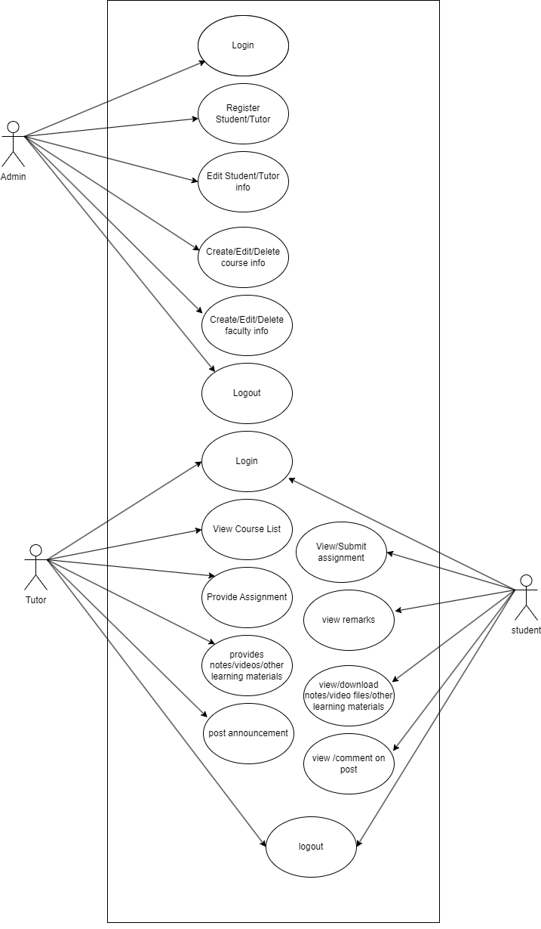

Figure 3: Use Case Diagram

The functional requirements for the Online Tutor project include:

* User registration and login: The system should allow users to register and create accounts. Users should be able to log in to the system using their credentials.
* User management: The system should allow the admin to manage users, including tutors and students. The admin should be able to add, edit, and delete users.
* Course management: The system should allow the admin to manage courses, including adding, editing, and deleting courses. The system should also allow tutors to create courses and add them to the system.
* Assignment management: The system should allow tutors to create assignments and post them for students. The system should allow students to submit assignments and receive feedback from tutors.
* Note management: The system should allow tutors to upload notes for students to access. Students should be able to view and download the notes.
* Post management: The system should allow tutors to create posts that students can view and comment on.
* Comment management: The system should allow students to comment on posts and assignments.
* User profile management: The system should allow users to manage their profiles, including updating their personal information and profile pictures.
* Search functionality: The system should allow users to search for courses, assignments, and notes.

1. **Non-Functional Requirement**

The non-functional requirements section should describe the system's performance, security, and usability standards. The non-functional requirements for the Online Tutor project include:

* Performance: The system should be responsive and load quickly.
* Security: The system should be secure and protect user data and information.
* Usability: The system should be easy to use and navigate.

### 3.1.5 Data Modeling (ER-Diagram)

An Entity–relationship model (ER model) describes the structure of a database with the help of a diagram, which is known as Entity Relationship Diagram (ER Diagram). An ER model is a design or blueprint of a database that can later be implemented as a database. The main components of E-R model are: entity set and relationship set.

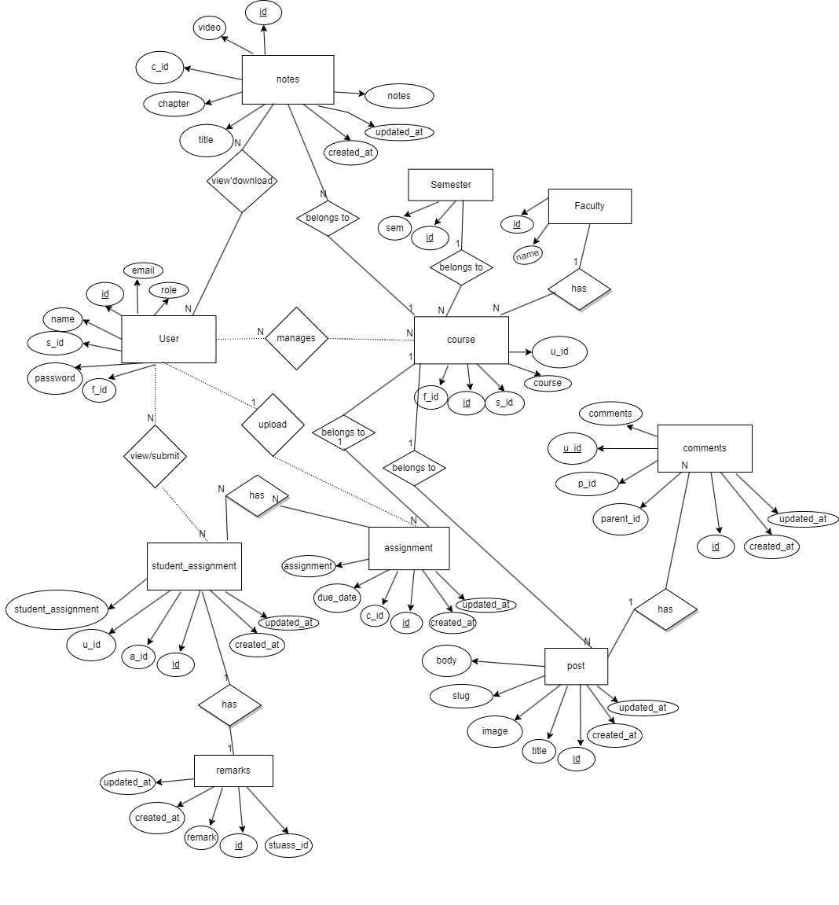

Figure 4: ER Diagram

### 3.1.6 Process Modeling

Data Flow diagram is a graphical representation of flow of data throughout the information system. Data flow diagrams illustrate how data is processed by a system in terms of inputs and outputs. DFD graphically representing the functions, or processes, which capture, manipulate, store, and distribute data between a system and its environment and between components of a system. The visual representation makes it a good communication tool between User and System designer. Structure of DFD allows starting from a broad overview and expands it to a hierarchy of detailed diagram.

Data Flow Diagram (DFD)

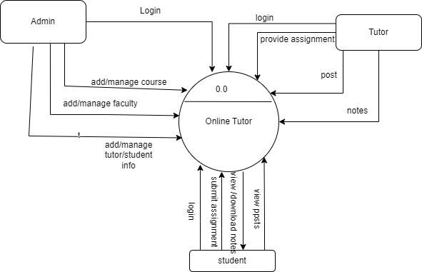

Figure 5: Level-0 DFD

Level:1(DFD)

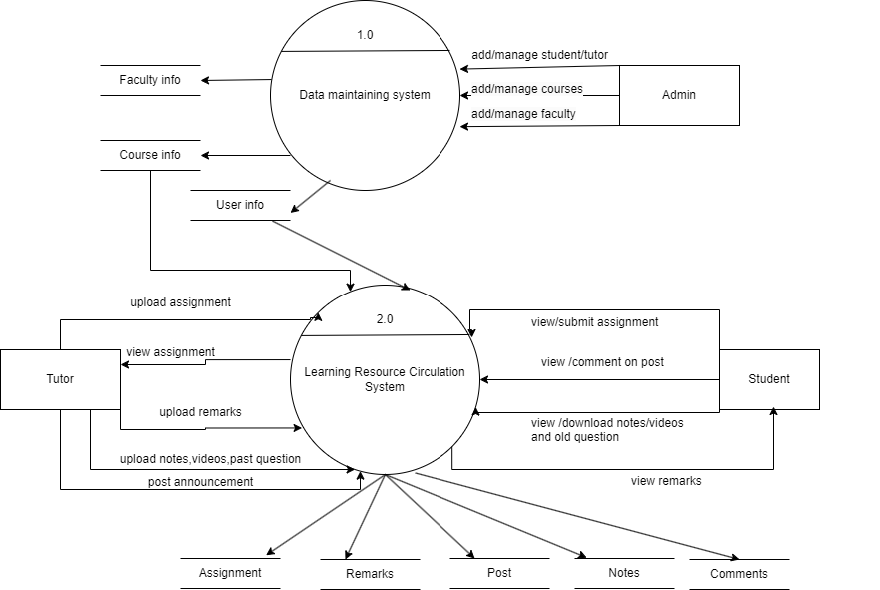

Figure 6: Level-1 DFD

Level :2 (DFD)

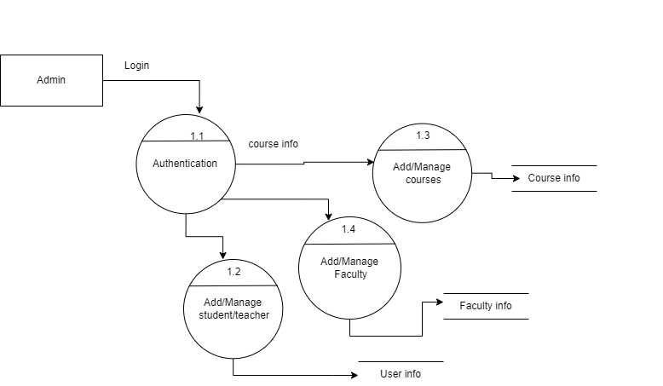

Figure 7: level-2 (Data Maintaining System)

Level:2 (DFD)

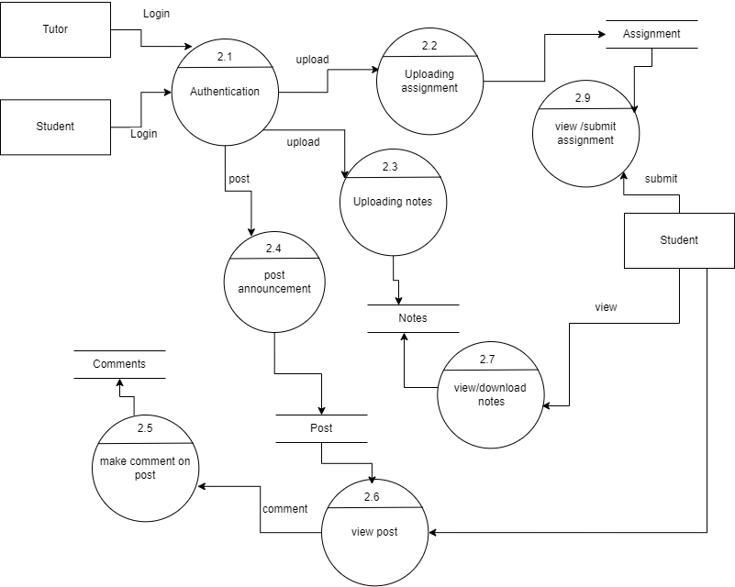

Figure 8: Level-2(Learning Resource Circulation System)

## 3.2 System Design

### 3.2.1 Architecture Design

An architectural diagram for a software project is a visual representation of the system's overall structure and how its components interact with each other. In the case of online tutor project, the architectural diagram provides a high-level overview of the system and its various components, including the user interface, database, application server, and external systems or services.

The diagram helps to illustrate how these components fit together and how data flows through the system. It can also help to identify potential bottlenecks or areas of the system that may require optimization.

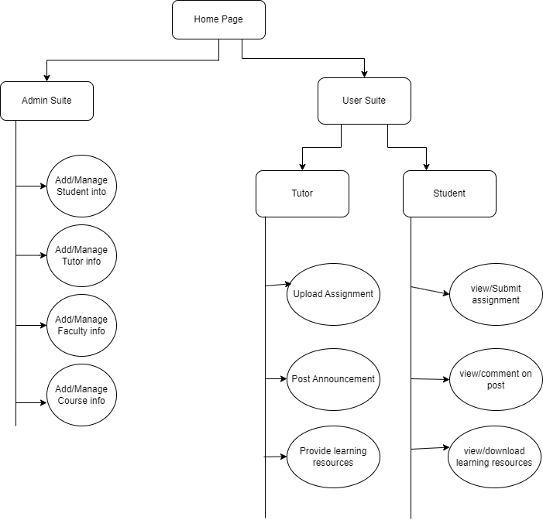

Figure 9: Architecture Design

### 3.2.2 Database Schema Diagram

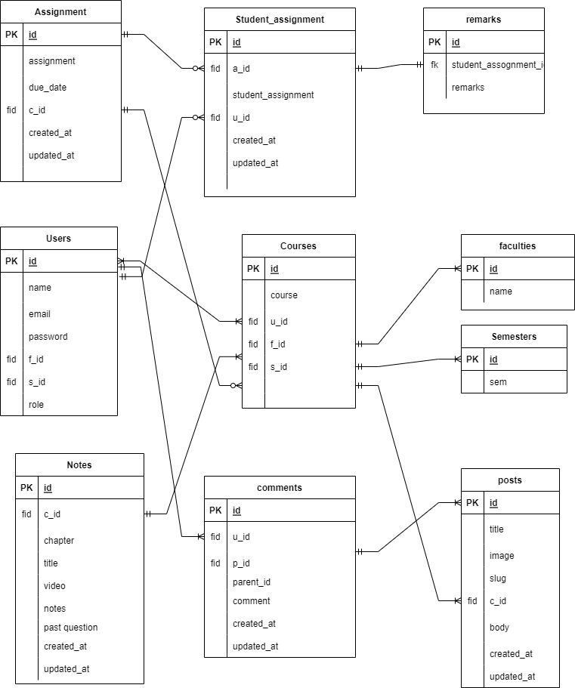

Figure 10: Database Schema Desig

### 3.2.3 Interface Design

User interface design is a critical aspect of any software application that determines how users interact with the technology. In the context of our project, "Online Tutor," the interface design plays a significant role in providing an effective learning environment for students, as well as easy management for administrators and tutors.

The project is designed to provide a platform for three different user types: admin, tutor, and student. The admin has full control over the system and can manage tutors, students, courses, and faculty. The tutor can create assignments, provide notes, and post updates for students, while the student can upload assignments, view and download notes, and view and comment on posts.

The interface design for this project is focused on creating a user-friendly experience that allows for easy navigation and seamless interaction. The dashboard for each user type is specifically designed to provide quick access to essential features and functionalities.

For students, the interface design includes easy access to their courses, assignments, and notes. The student dashboard also provides an intuitive interface for uploading and submitting assignments, viewing and commenting on posts, and accessing course materials.

For tutors, the interface design provides quick access to their courses, students, and assignments. The tutor dashboard also includes features for creating and managing assignments, providing notes, and posting updates for students.

The admin interface design is specifically designed to provide complete control over the system. The admin dashboard includes features for managing users, courses, assignments, and faculty. The design is user-friendly and provides a straightforward interface for managing the system.

Overall, the interface design for the "Online Tutor" project is focused on providing a seamless and efficient user experience. The design is intended to simplify the learning process for students, while also making it easy for administrators and tutors to manage the system effectively.

# Chapter 4: Implementation and Testing

## 4.1. Implementation

Implementation sees that plans and strategies are turned into action that achieve strategic objective and goals. Implementation is much significant than planning. Strategic implementation critical to a project success, addressing who, where, when, and how of reaching the desired goals and objectives.

### 4.1.1. Tools Used

**Front End Tools**

Front End development and Fronts End programming languages create what a user interacts with HTML, CSS, and JavaScript are the three Front End languages. Each language and tool has their own specific function.

Some of the tools used are:

* **HTML:** The Hyper Text Markup Language, or HTML is the standard markup language for documents designed to be displayed in a web browser. It can be assisted by technologies such as Cascading Style Sheets (CSS) and scripting languages such as JavaScript. HTML is a markup language that web browsers use to interpret and compose text, images, and other material into visual or audible web pages. Default characteristics for every item of HTML markup are defined in the browser, and these characteristics can be altered or enhanced by the web page designer's additional use of CSS.
* **CSS:** Stands for "Cascading Style Sheet." Cascading style sheets are used to format the layout of Web pages. They can be used to define text styles, table sizes, and other aspects of Web pages that previously could only be defined in a page's HTML.

CSS helps Web developers create a uniform look across several pages of a Web site. Instead of defining the style of each table and each block of text within a page's HTML, commonly used styles need to be defined only once in a CSS document. Once the style is defined in cascading style sheet, it can be used by any page that references the CSS file. Plus, CSS makes it easy to change styles across several pages at once.

* **JavaScript:** JavaScript is a programming language commonly used in web development. It was originally developed by Netscape as a means to add dynamic and interactive elements to websites. While JavaScript is influenced by Java, the syntax is more similar

to C and is based on ECMA Script, a scripting language developed by Sun Microsystems. JavaScript is a client-side scripting language, which means the source code is processed by the client's web browser rather than on the web server. This means JavaScript functions can run after a webpage has loaded without communicating with the server.

* **Bootstrap:** Bootstrap is a giant collection of handy, reusable bits of code written in HTML, CSS, and JavaScript. It’s also a frontend development framework that enables developers and designers to quickly build fully responsive websites. Essentially, Bootstrap saves you from writing lots of CSS code, giving you more time to spend on designing webpage.
* **Laravel:** Laravel is a back-end PHP-based and open-source framework used for building a wide range of custom web applications. It's an entirely server-side framework that manages data with the help of Model-View-Controller (MVC) design which breaks an application back-end architecture into logical parts.

**Back End Tools**

The back end of a website consists of a server, an application, and a database. A back-end developer builds and maintains the technology that powers those components which, together, enable the user facing side of the website to event exist in the first place.

* **PHP:** Stands for "Hypertext Preprocessor." (It is a recursive acronym, if you can understand what that means.) PHP is an HTML-embedded Web scripting language. This means PHP code can be inserted into the HTML of a Web page. When a PHP page is accessed, the PHP code is read or "parsed" by the server the page resides on. The outputs from the PHP functions on the page are typically returned as HTML code, which can be read by the browser. Because the PHP code is transformed into HTML before the page is loaded, users cannot view the PHP code on a page. This makes PHP pages secure enough to access databases and other secure information.
* **MYSQL**: MYSQL is a powerful open-source database server built based on a relational Database management system (RDBMS) and is capable of handling a large concurrent database connection. When combined together, talented PHP and MYSQL developers can build very powerful and scalable Web / Internet / Intranet Applications. PHP and MYSQL are referred to as development tools.  MYSQL are Open Source, meaning that they are free development tools, and there is a large community of dedicated volunteer programmers who contribute to make improvements and are continuously adding features to it. The development tools and database servers that require licensing costs have limited programming resources compared to open-source development tools, which have an enormous and fast growing dedicated and knowledgeable community that extends around the world.
* **XAMPP Server:** XAMPP is a free and open-source cross-platform web server solution stack package developed by Apache Friends, consisting mainly of the Apache HTTP Server, Maria DB database, and interpreters for scripts written in the PHP and Perl programming languages. Since most actual web server deployments use the same components as XAMPP, it makes transitioning from a local test server to a live server possible.

XAMPP's ease of deployment means a WAMP or LAMP stack can be installed quickly and simply on an operating system by a developer, with the advantage that common add-in applications such as Word Press and Joomla can also be installed with similar ease using Bit Nami.

* **Laravel**: Laravel has been popular among web developers for more than 10 years and it remains one of the most preferred server-side frameworks on PHP. According to the Stack Overflow Developer Survey, 51.4% of respondents  [prefer](https://insights.stackoverflow.com/survey/2020#technology-programming-scripting-and-markup-languages-professional-developers) to use Laravel for building their web applications. At the same time, JetBrains [claims](https://www.jetbrains.com/lp/devecosystem-2020/php/) that Laravel is ranked among the three most popular PHP frameworks with half of PHP developers using it.

## 4.2 Testing

Testing is the integral part of the software development process. It is the process of verifying and validating that a software meets the requirements based on the design and development proposed. This Project is focused on the validation and verification of the user input data from the very beginning. A single module is created for the application part of the project. The Project is broken down into several modules and configured as necessary per requirements. Testing is performed after completion of each module and after their integration also.

### 4.2.1 Unit Testing

Unit testing, a testing technique using which individual modules are tested to determine if there are any issues by the developer himself. It is concerned with functional correctness of the standalone modules. The main aim is to isolate each unit of the system to identify, analyze and fix the defects. It reduces Defects in the newly developed features or reduces bugs when changing the existing functionality.

### 4.2.1.1 Test cases

Unit testing, a testing technique using which individual modules are tested to determine if there are any issues by the developer himself. It is concerned with functional correctness of the standalone modules. The main aim is to isolate each unit of the system to identify, analyze and fix the defects. It reduces defects in the newly developed features or reduces bugs when changing the existing functionality.

Table 1: Admin login

|  |  |  |  |  |
| --- | --- | --- | --- | --- |
| **Test case ID** | **Scenario** | **Step** | **Test Data** | **Expected Result** |
| T01 | Check users input for login | * Go to the site * Enter email and password | Email: nisa_csit2075@lict.edu.np  Password: admin123 | Successfully login as redirected to dashboard |
| T02 | Check for users input for login with partial data | * Go to the site * Enter email and password | Email:  nisa_csit2075@lict.edu.np  Password: 567 | Error invalid message ‘invalid username and password” redirect to login |

### 

Table 2: Student login

|  |  |  |  |  |
| --- | --- | --- | --- | --- |
| **Test Case ID** | **Scenario** | **Step** | **Test Data** | **Excepted Result** |
| T01 | Check register data for login | * Go to the site   Enter email and password | Email: neetu@gmail.com  Password: neetu123 | Successfully login as redirected to student homepage |
| T02 | Check for users input for login with partial data | * Go to the site   Enter email and password | Email: user@user.com  Password: 567 | Error invalid message ‘invalid username and password |

Table 3: Tutor login

|  |  |  |  |  |
| --- | --- | --- | --- | --- |
| **Test Case ID** | **Scenario** | **Step** | **Test Data** | **Excepted Result** |
| T01 | Check register data for login | * Go to the site * Enter email and password | Email: macharya@gmail.com  Password: macharya123 | Successfully login as redirected to tutor homepage |
| T02 | Check for users input for login with partial data | * Go to the site * Enter email and password | Email: user@user.com  Password: 567 | Error invalid message ‘invalid username and password |

### 4.2.2 Features Testing

Features testing is the process of making changes in software system to add one or more new features or to make modifications in the already existing features.

#### 

# Chapter:5 Risk Analysis

Some of the risks that are involved in our proposed system are:

* System Maintenance: The online tutor system may require ongoing maintenance to ensure optimal performance and to address any bugs or vulnerabilities that are discovered.
* Changes in User Needs: Over time, the needs and preferences of the system users may change, requiring updates or modifications to the system.
* Technological Obsolescence: Advances in technology may render the online tutor system outdated or incompatible with newer systems, making it difficult to maintain or support.
* Regulatory Changes: Changes in regulatory requirements, such as data protection or privacy laws, may require updates or modifications to the online tutor system.
* Cybersecurity Threats: The online tutor system may be vulnerable to cyber attacks, such as phishing scams, malware, or hacking attempts, which could compromise user data or system integrity.

**[Risk1]**

The requirement we gathered was not sufficient to satisfy the end user. As requirements of the end user changes rapidly.

**[Strategy1]**

Especial focus and concentration were given about the requirements of the end user and we develop the flexible system so that we can make the further change in system in near future.

**[Risk2]**

The end user might feel difficult to use the system and may not understand how to operate the system.

**[Startegy2]**

User friendly GUI should be implemented and training should be given to the users, if possible, otherwise the user manual should be provided.

# Chapter:6 Conclusion and Discussion

In conclusion, the online tutor project is a complex system that involves multiple users, functionalities, and risks. The project requires careful planning, design, and implementation to ensure that it meets the needs of the stakeholders and provides a secure, reliable, and user-friendly learning platform. The project involves several key components, such as user management, course management, assignment management, note sharing, and discussion forums, all of which must be integrated and tested to ensure smooth operation. The project also involves several risks, such as security breaches, technical failures, user errors, scope creep, and third-party dependencies, which must be identified, assessed, and managed throughout the project lifecycle. Overall, the success of the online tutor project depends on effective collaboration, communication, and risk management among the project team, stakeholders, and users.

# References

[1] "What is Incremental Model in SDLC? Advantages & Disadvantages @ www.guru99.com." [Online]. Available: https://www.guru99.com/what-is-incremental-model-in-sdlc-advantages-disadvantages.html.

[2] "Risk Management in Software Development Projects @ 2015 International Conference on Enterprise Systems (ES)." [Online]. Available: https://ieeexplore.ieee.org/abstract/document/7301859.

[3] "A Web-Based Assignment Management System: Design, Implementation and Evaluation @ 2018 International Conference on Information Management and Technology (ICIMTech)." [Online]. Available: https://ieeexplore.ieee.org/abstract/document/8527229.

[4] "User Authentication and Authorization in Web Applications @ 2017 International Conference on Innovations in Information, Embedded and Communication Systems (ICIIECS)." [Online]. Available: https://ieeexplore.ieee.org/abstract/document/8273105.

[5] "Design and Implementation of a Secure User Management System for Web Applications @ Procedia Computer Science." [Online]. Available: https://www.sciencedirect.com/science/article/pii/S1877050915028173.

[6] "Design and Implementation of a Web-Based Course Management System @ 2009 International Conference on New Trends in Information and Service Science." [Online]. Available: https://ieeexplore.ieee.org/abstract/document/5334097.

[7] "A Web-Based Platform for Collaborative Learning @ Procedia Computer Science." [Online]. Available: https://www.sciencedirect.com/science/article/pii/S1877050919319941.

[8] "Design and Implementation of a Web-Based Discussion Forum for Collaborative Learning @ 2014 International Conference on Computing, Communication and Information Technology (ICCCIT)." [Online]. Available: https://ieeexplore.ieee.org/abstract/document/7032093.

# Appendix

* **Admin Portal:**

Here, we implemented the insertion, deletion, retrieve and edit operations.

For this the admin will login to the system through Online Tutor.

Admin has the authority to register the Tutor and Student data then login.

Screenshot of this work:

While admin click on Sign in button:

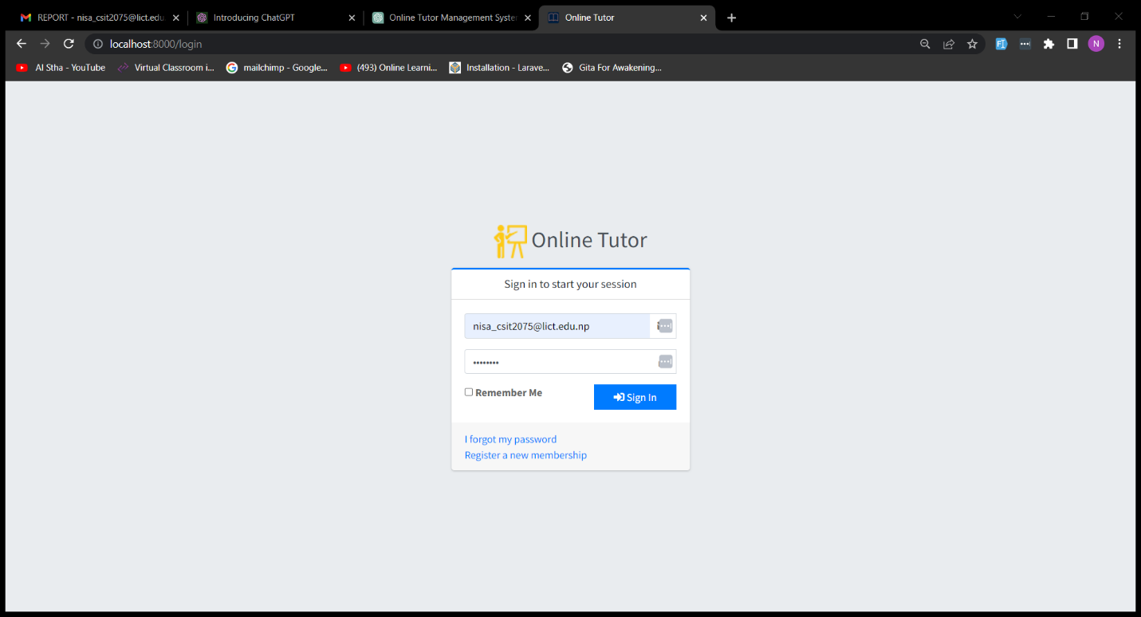

Figure 11: Admin Login

1. Username input field
2. Password input field
3. SIGN IN button – while we click the button with entering valid username and password, get enter into admin panel. If the username and password of the admin is authorized then admin is directed to admin panel and insert data.

**-Admin Dashboard**

Here are the information’s about all data that are available in Online Tutor.

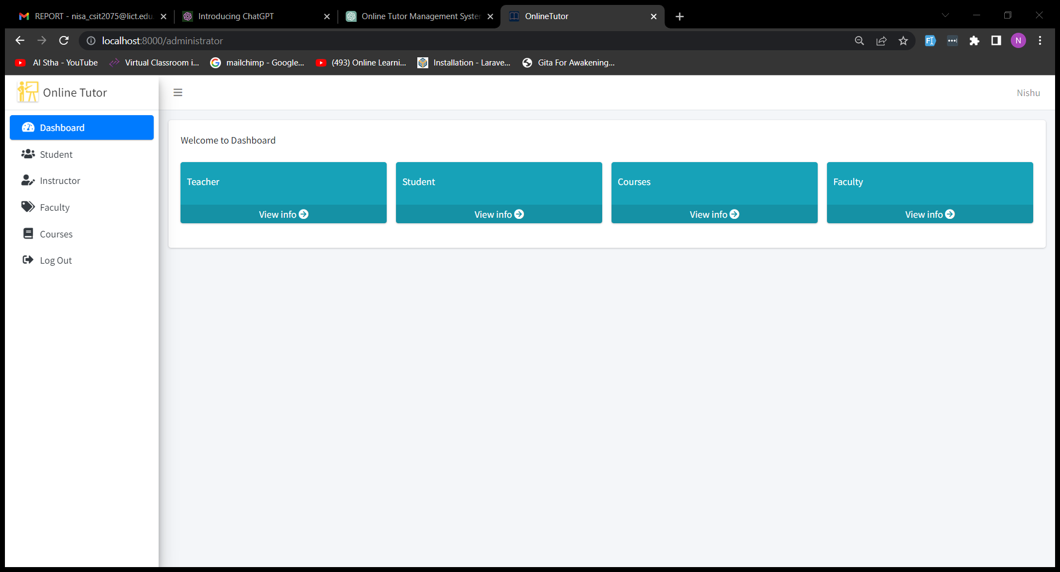

Figure 12: Dashboard

**-Student Data**

Here are the Student information.

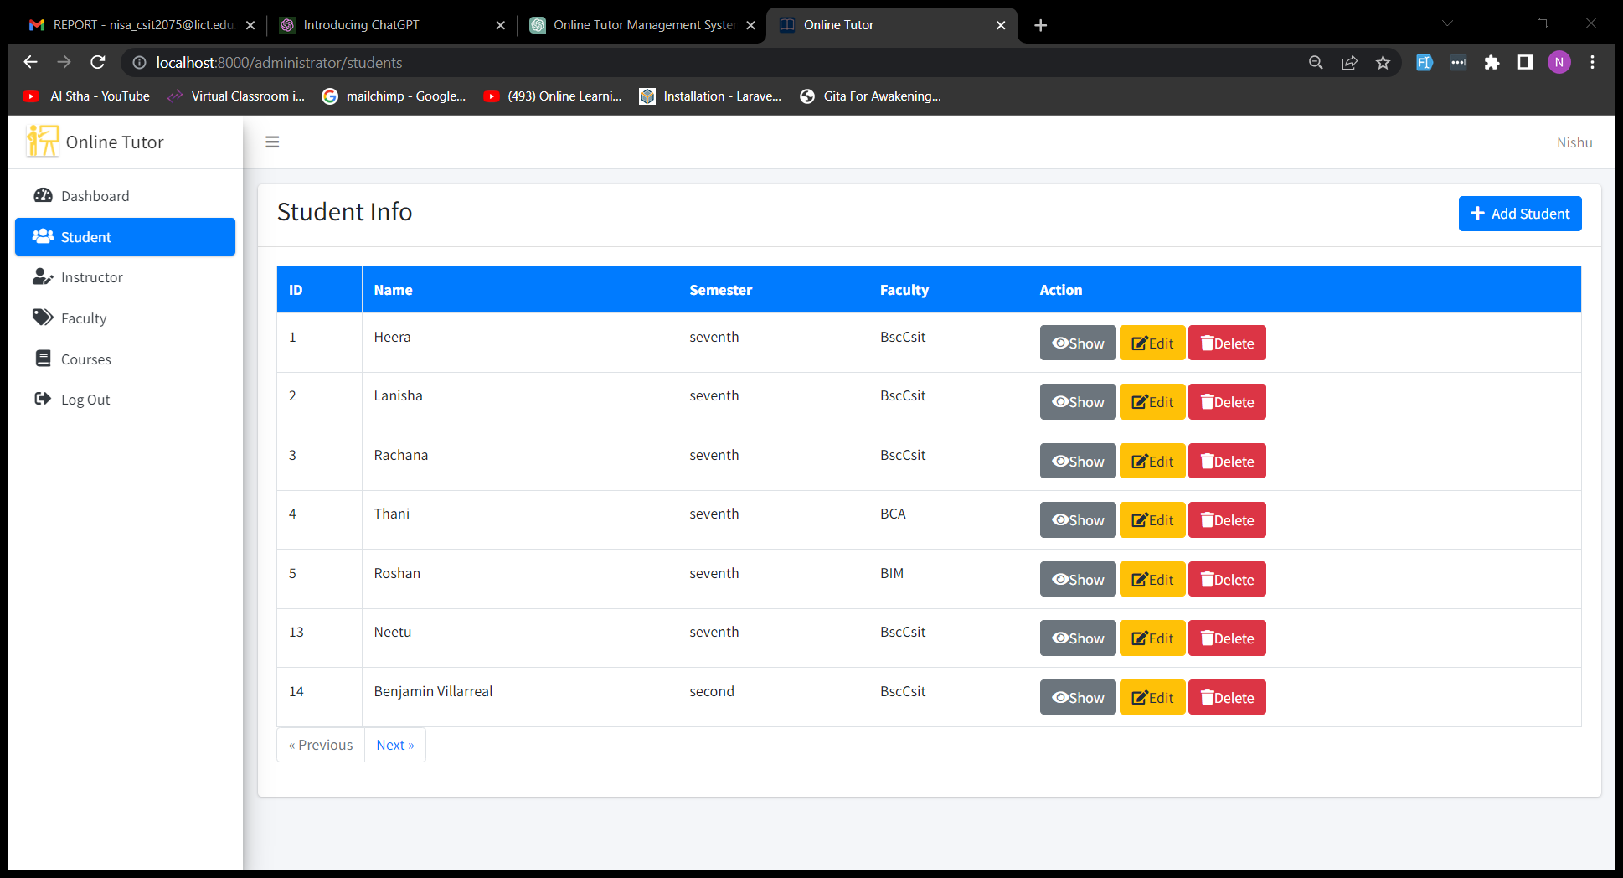

Figure 13: Student Information

**-Course Data**

Here are Course data.

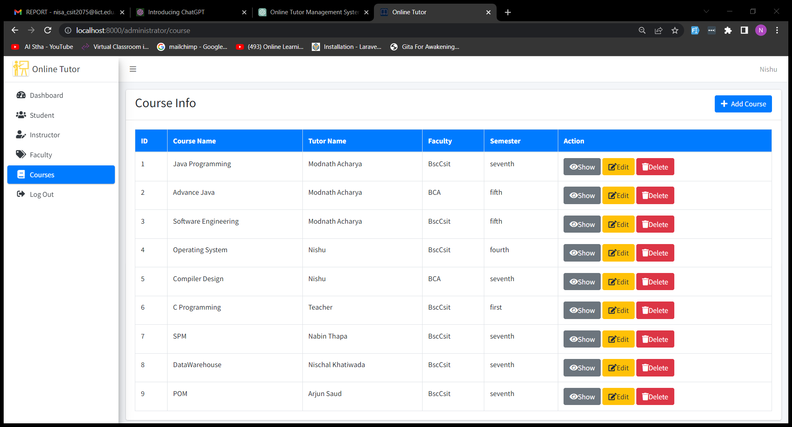

Figure 14: Course data

**-Adding Course Details**

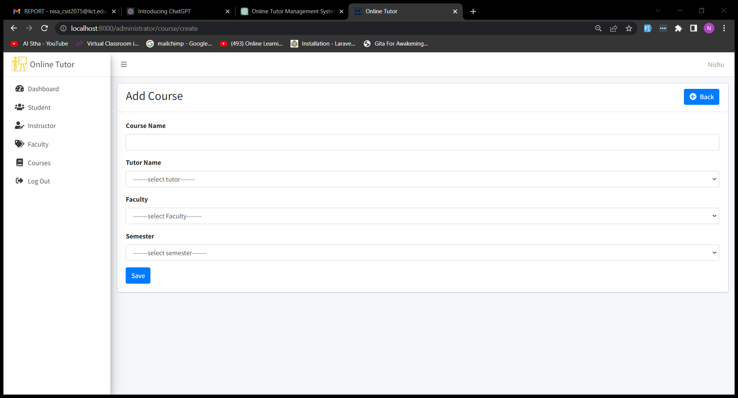

Figure 15: Adding Course details

-**Tutor dashboard**

If any tutor login to the system, then tutor dashboard looks like this:

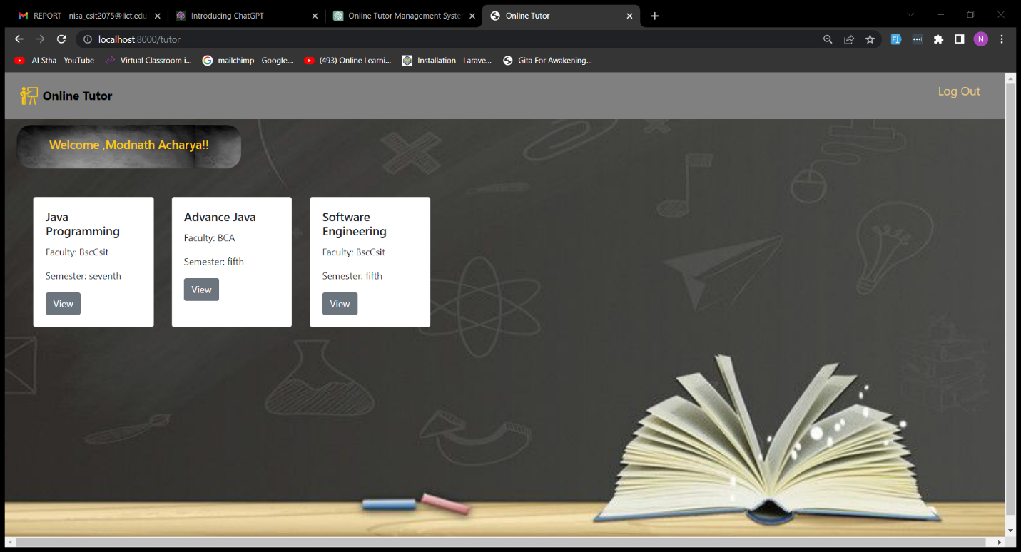

Figure 16: tutor dashboard

If tutor wants to provide assignment for particular course then,

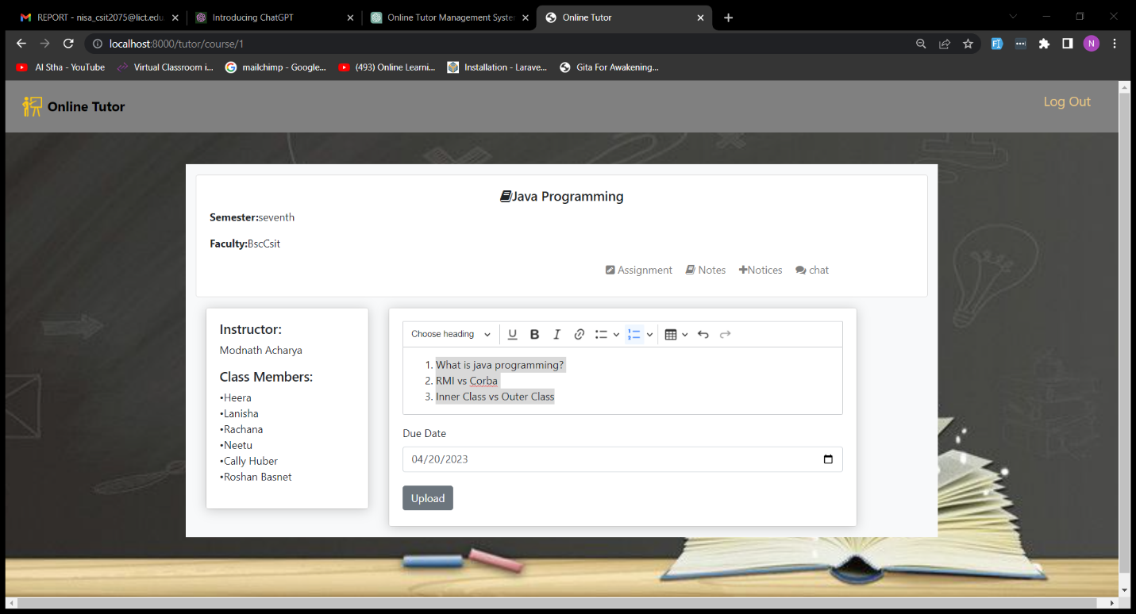

Figure 17: Uploading Assignment

-**Student Dashboard(View)**

When student login to the system:

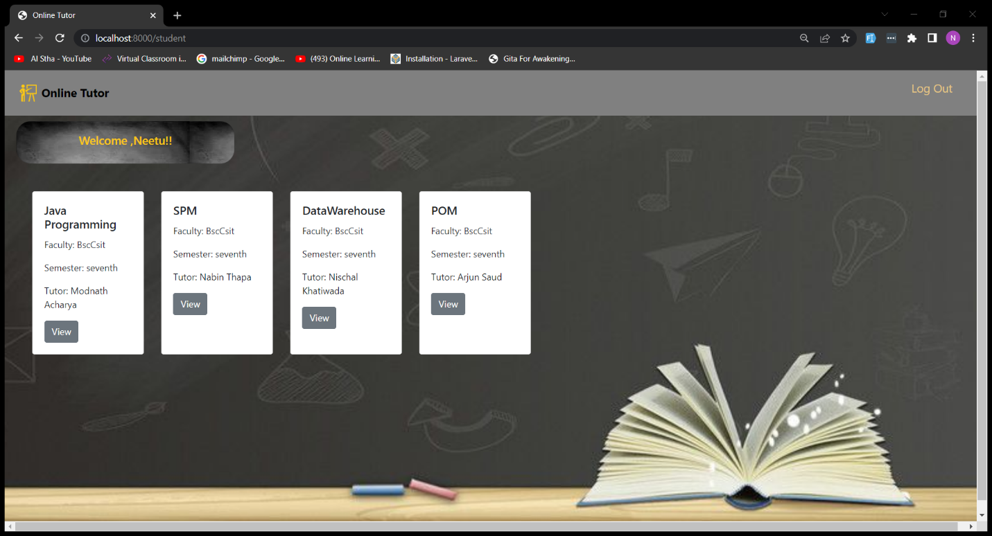

Figure : Student Dashboard

-**Student view and upload assignment**

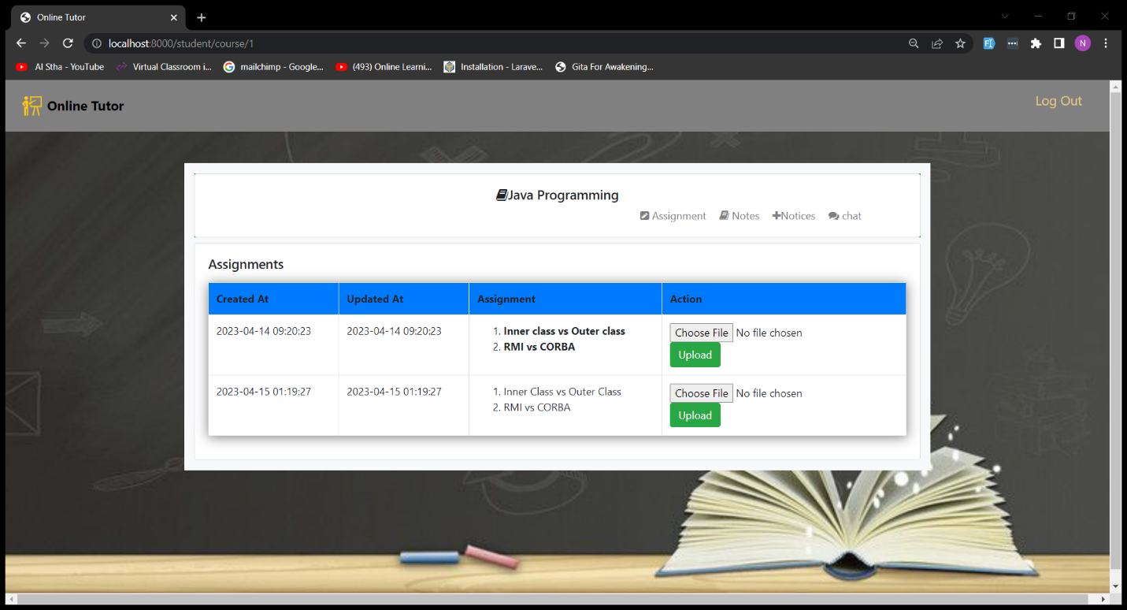

Figure 19: Student viewing assignment and uploading

**-Tutor uploading notes**

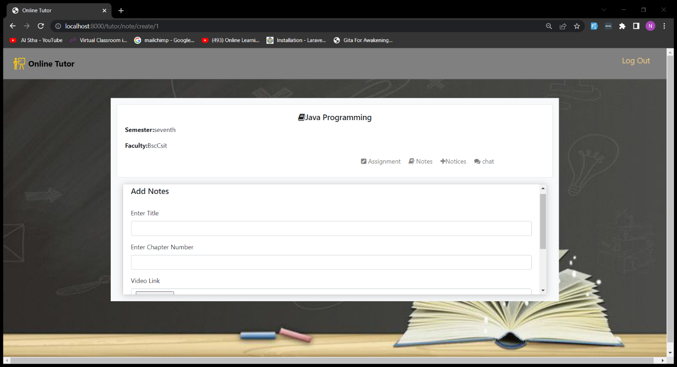

Figure 20: Notes uploading page

-**view student’s assignment**

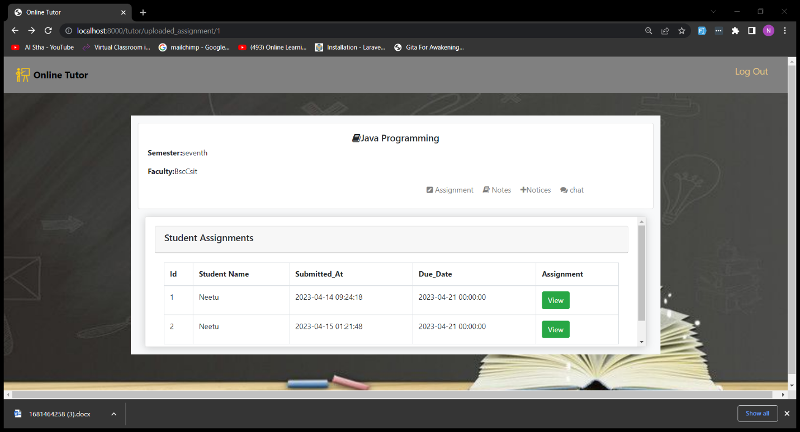

Figure 21: view student’s assignment